How to Use Google Maps as a Tool for Project-Based Learning

Search for google cloud platform

https://google.com/cloud/

Go there – make sure you’re signed in under the correct account

There’s a get5 started for free button – click that sucker.

When asked to describe your organisation or needs – choose class project / assignment

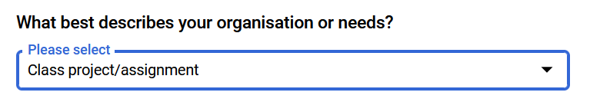

You’ll have to enter some contact details and then get the contact verified (phone SMS for me)

On the account type I selectd individual (not a business) – they were the only choices

To Create an API Key

Project

Create key

Restrict key